Name: Sally Phan
Year: 10

Colour Slapsh – Shoe

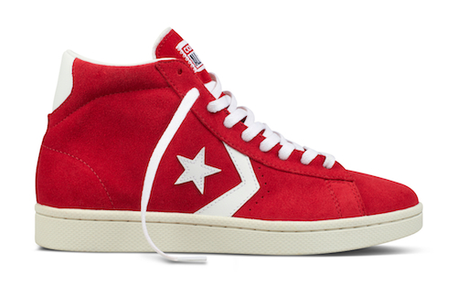
Step 1:

- Open the shoe image in Photoshop then select the Quick Selection Tool and select the shoe.
- Command + J to make the new layer with the shoe I selected already. Delete the mother layer.

Step 2:

- Command + T to make the shoe bigger and upside down.
- Select the Polygonal Lasso Tool to select a bit at the end of the shoe and then go to Edit -> Clear.

Step 3:

- Open the image of the red Paint Tossing Pack in Photoshop, then Command + A, Command + C to select all the image and go back the shoe side Command + V to put in.
- Press Command + T to make it looks good to the shoe and then go to Image -> Adjustment -> Levels to make the perfect colour for the red image.
- Select the Edit -> Perspective Wrap and make the curve follow the shoe.

Step 4:

- Choose 2 more image with the red and do the same thing like step 3.
- Open 1 more image with white and Command + A, Command + C to then Command + V to get it in. Then, put that layer under the layer 3, do the same thing before.

Step 5:

- Open the background copy it to the shoe image, Command + T to make it bigger and put it under the mother layer.

Step 5:

- Save it in JPG.

Here we go:

